**DAILY ONLINE ACTIVITIES SUMMARY**

|  |  |  |  |  |  |  |  |
| --- | --- | --- | --- | --- | --- | --- | --- |
| **Date:** | 14-06-2020 | | | | **Name:** | Gudugunti Anirudh | |
| **Sem & Sec** | IV - A | | | | **USN:** | 4AL18CS023 | |
| **Online Test Summary** | | | | | | | |
| **Subject** | | N/A | | | | | |
| **Max. Marks** | | N/A | | **Score** | | N/A | |
| **Certification Course Summary** | | | | | | | |
| **Course** | Data structures and algorithms in c++ | | | | | | |
| **Certificate Provider** | | | Udemy | **Duration** | | | **2.5hr** |
| **Coding Challenges** | | | | | | | |
| **Problem Statement:** 1: program to remove a substring of a string.  2: finding the min number of steps. | | | | | | | |
| **Status:** Completed | | | | | | | |
| **Uploaded the report in Github** | | | | yes | | | |
| **If yes Repository name** | | | | https://github.com/alvas-education-foundation/anirudh_gudugunti/tree/master/daily_progress | | | |
| **Uploaded the report in slack** | | | | yes | | | |

**Online Test Details:** Not conducted

**Certification Course Details:**

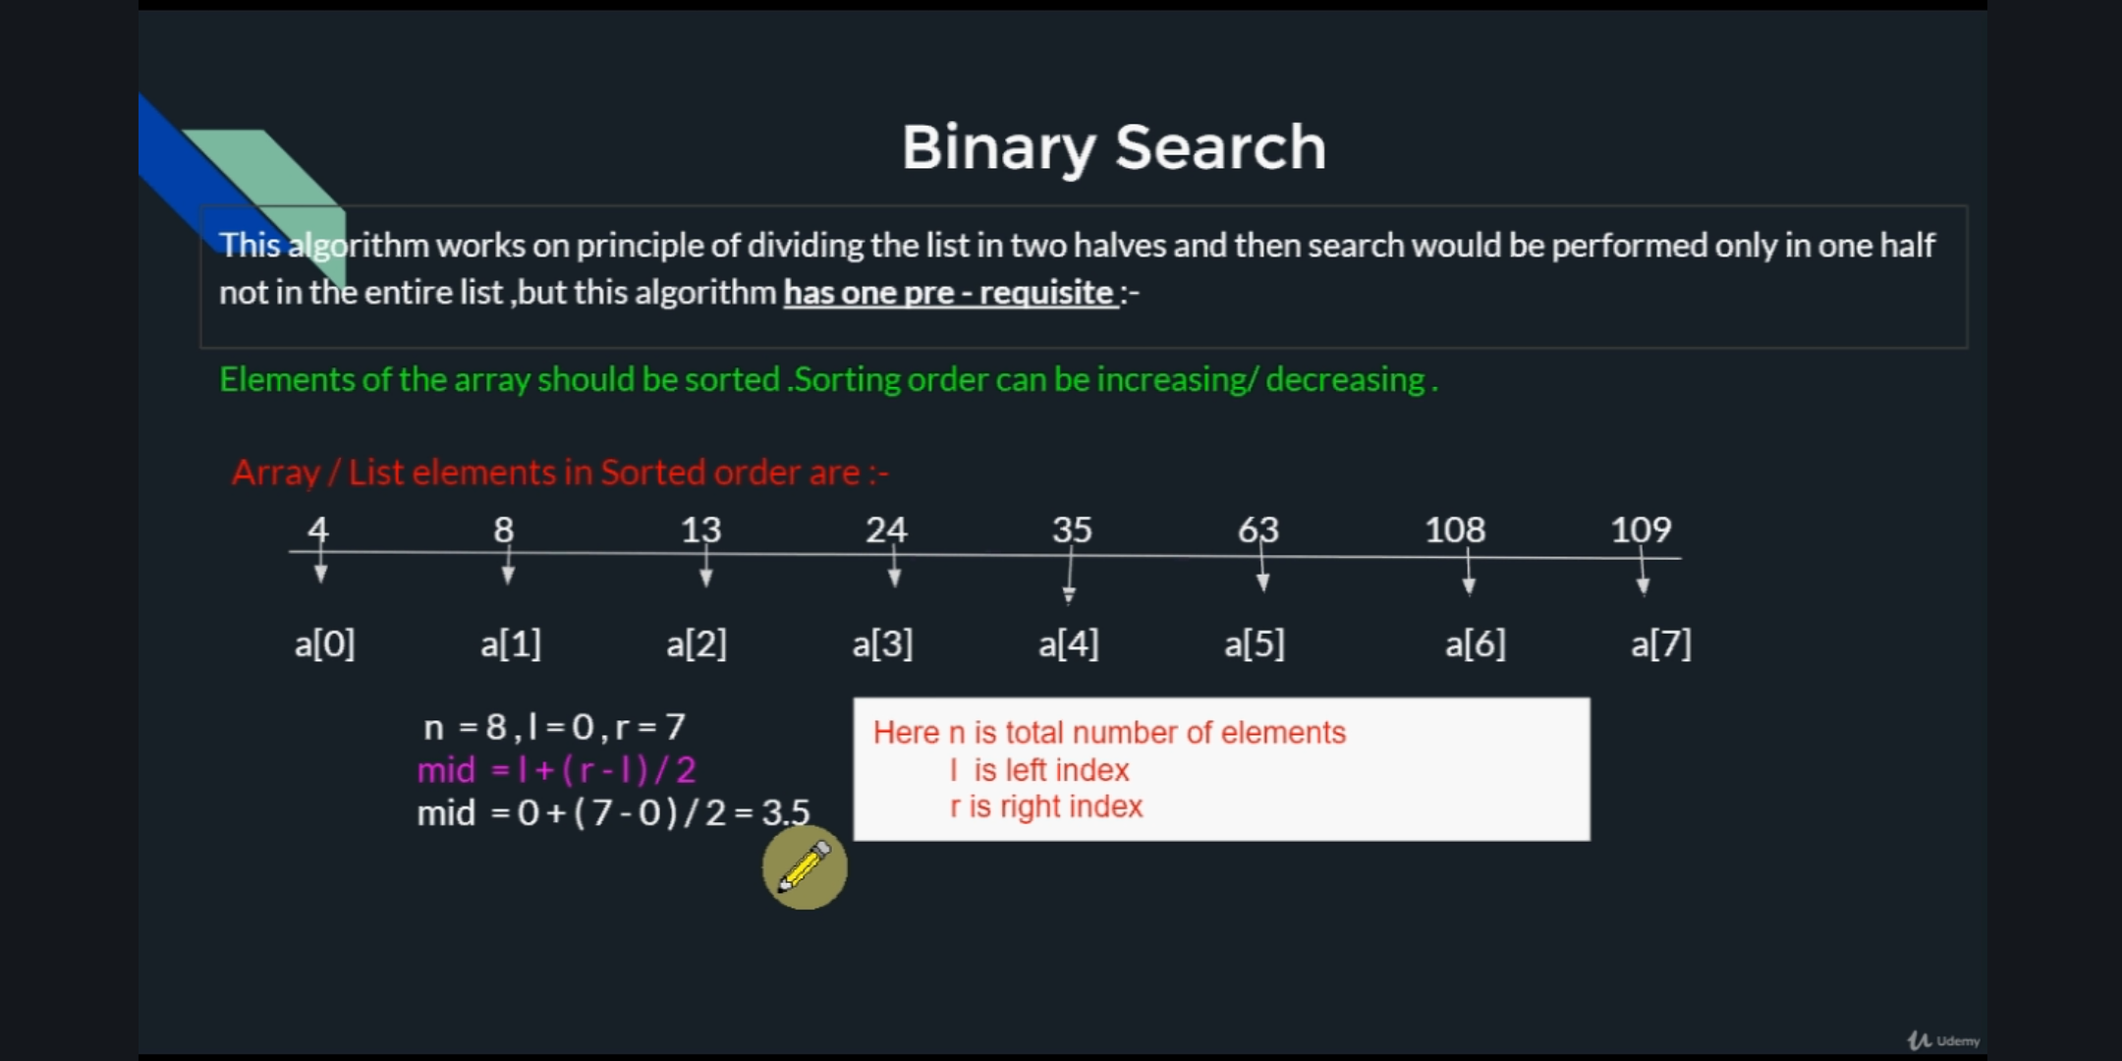

1. Introduction to binary search.

2. Representation of binary search with detailed steps.

3. Exmaples with neat diagrams.

C**oding Challenges Details:**

Problem 1: (using C language) program to remove a substring of a string.

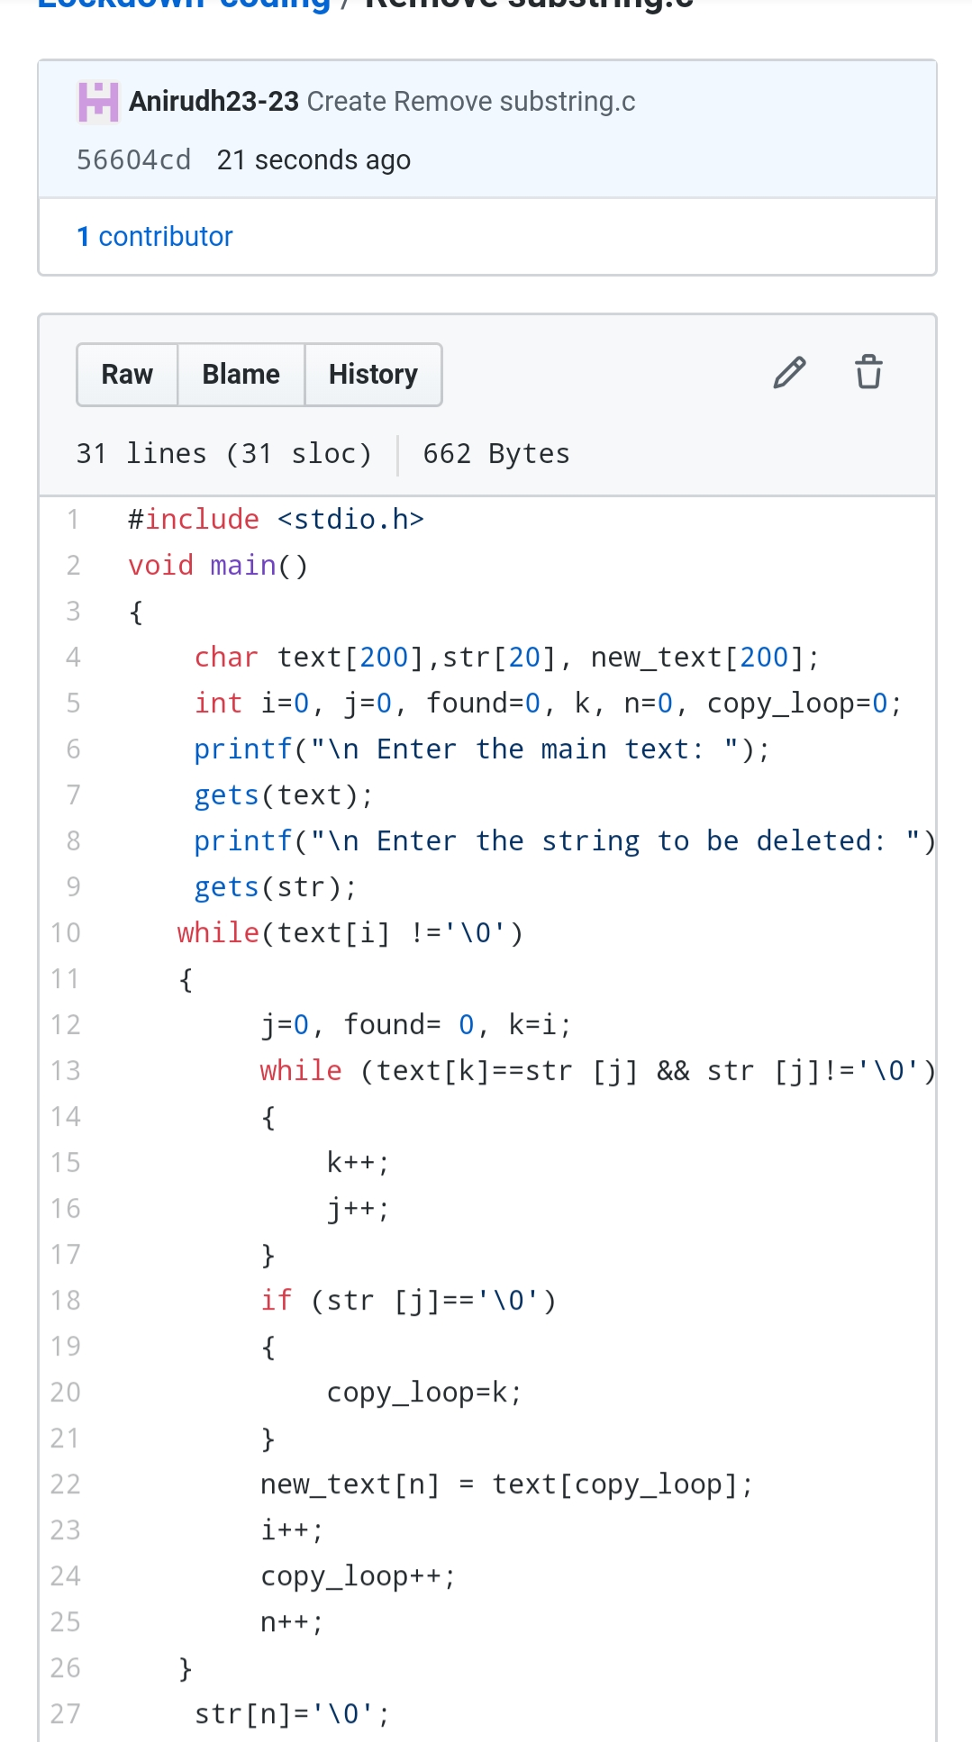

Problem 2: (using python) There are three integers k,m,n. You have to convert the number k to m by performing the given operations:

: Multiply k by n

: Decrease k by 2.

: Decrease k by 1.

:You have to perform the above operations to convert the integer from k to m and find the minimum steps.

